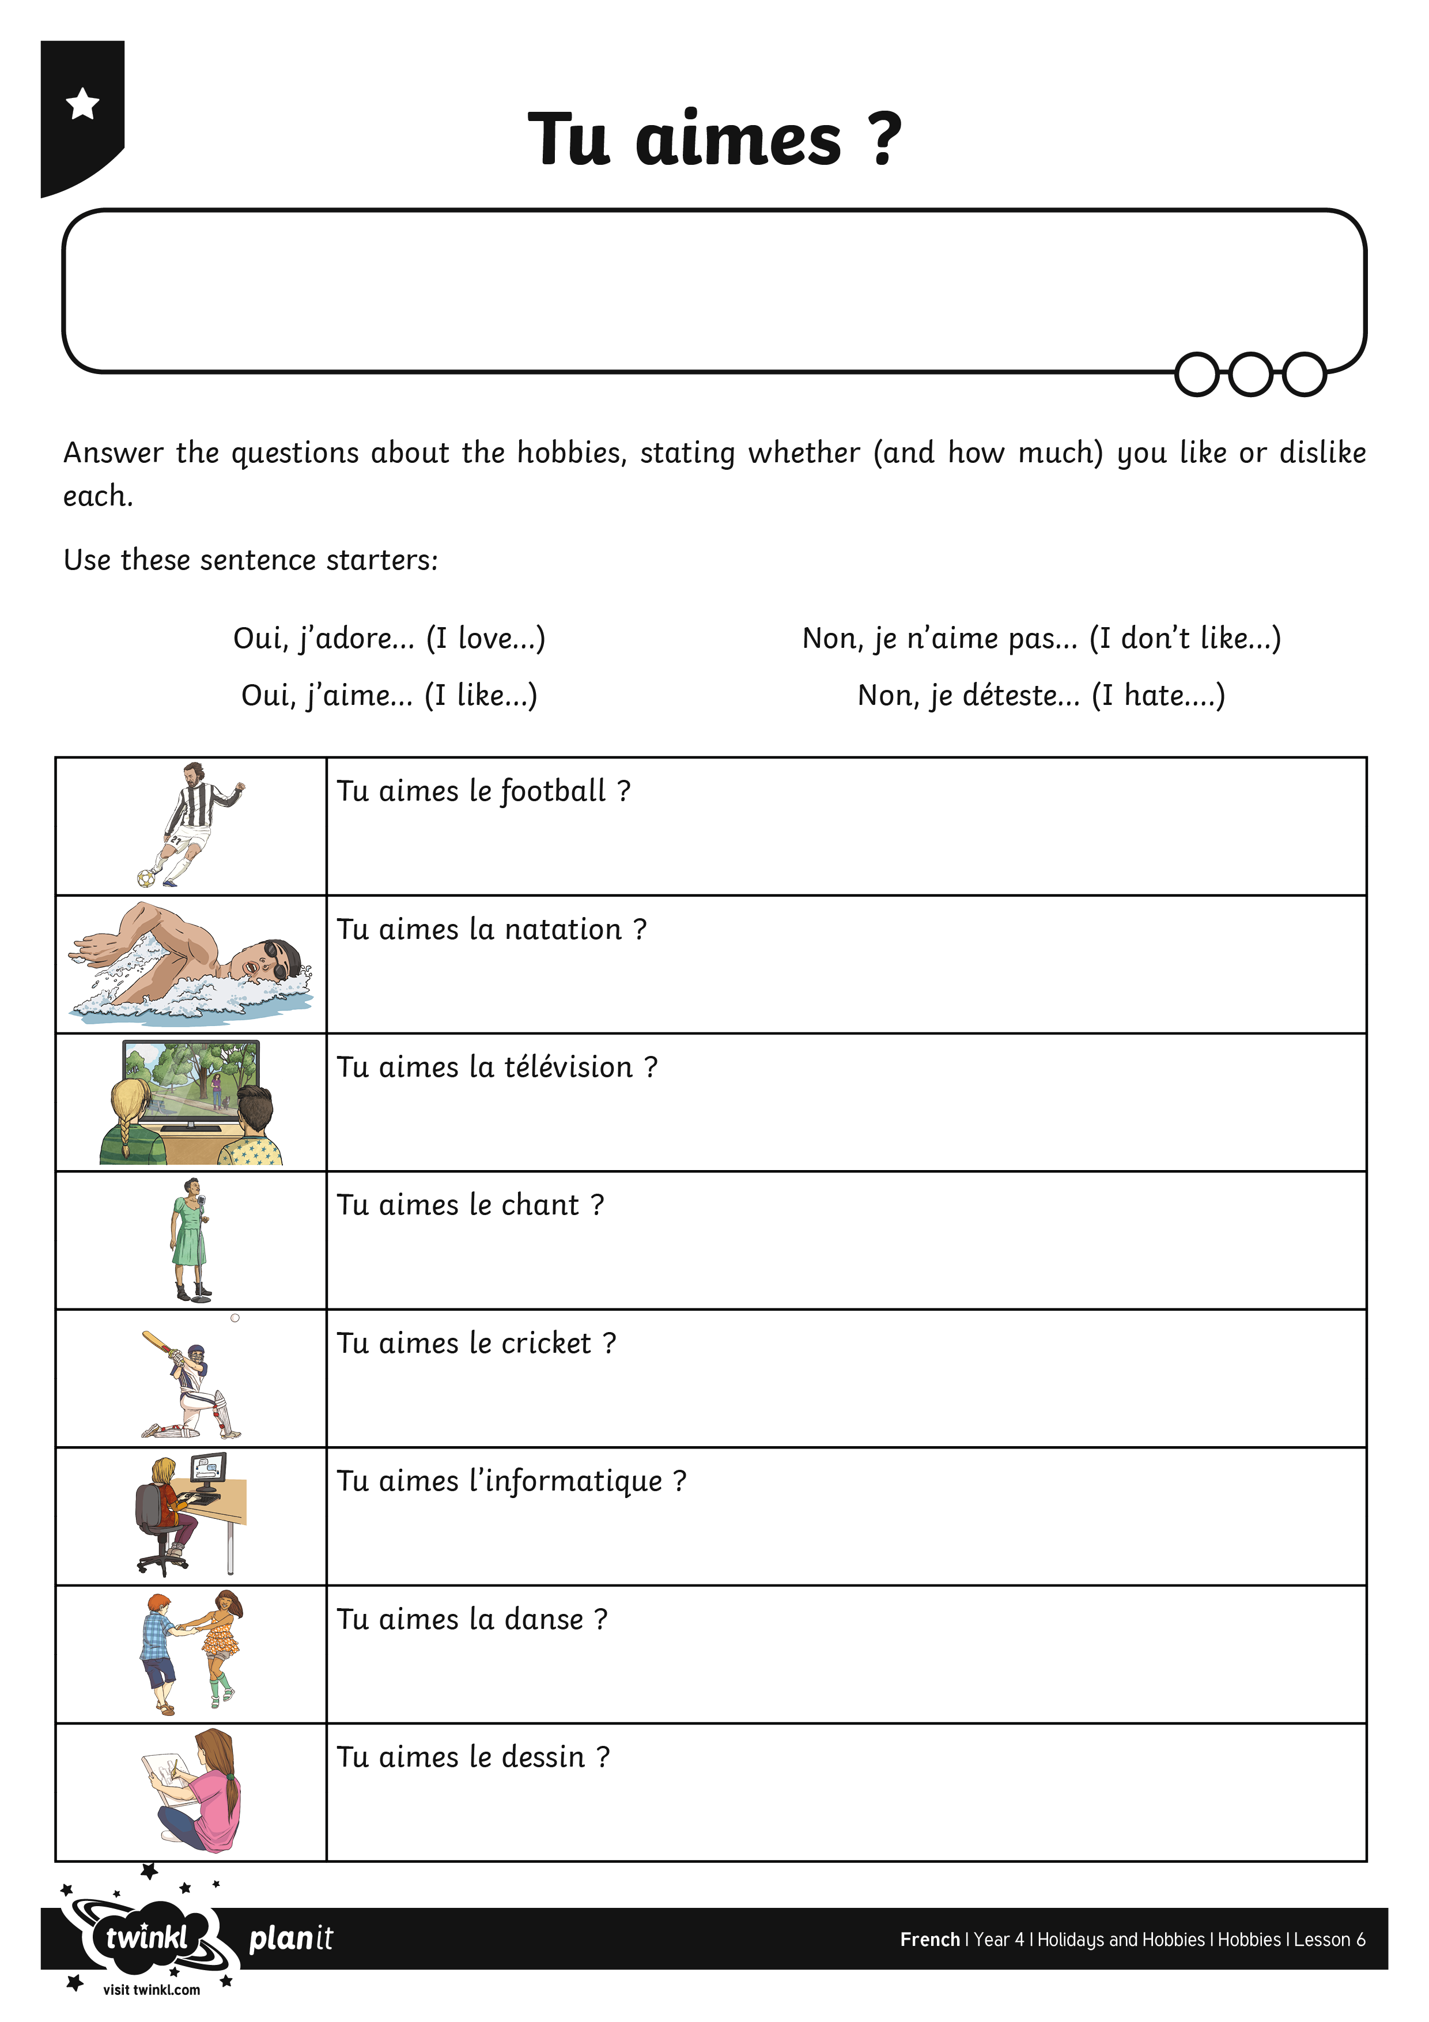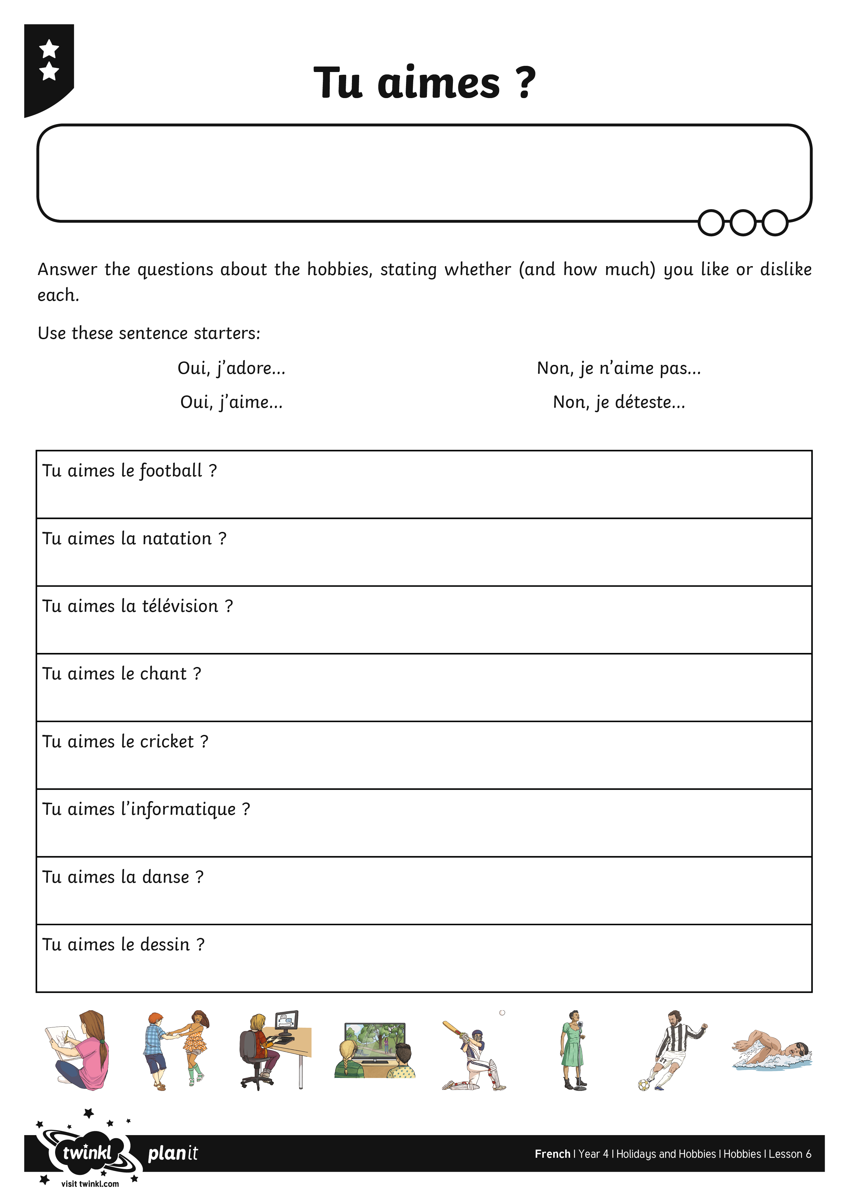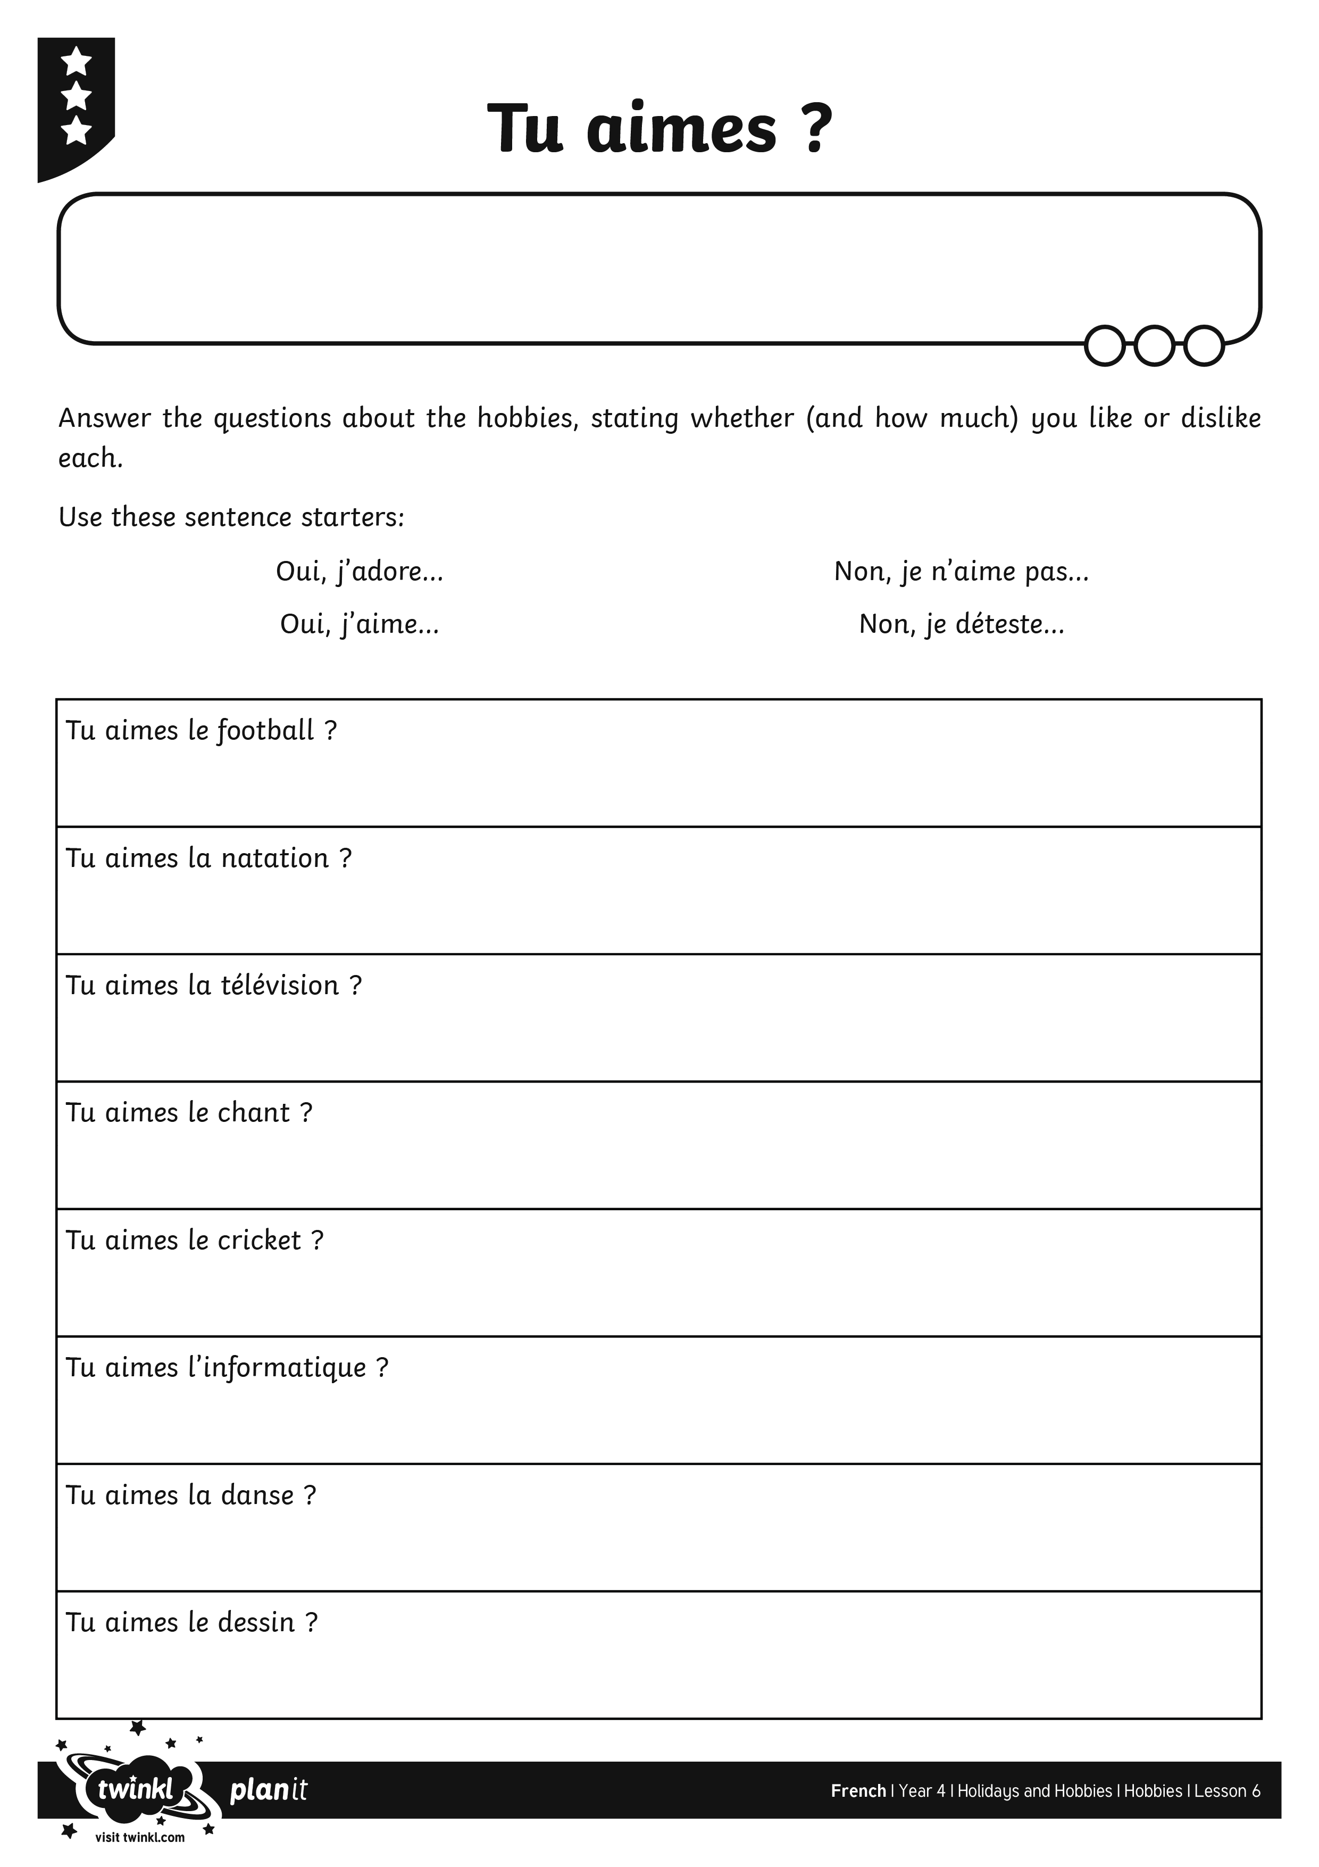
I can answer the question ‘Tu aimes ?’ in writing, using one of four sentence starters.

I can answer the question ‘Tu aimes ?’ in writing, using one of four sentence starters.

I can answer the question ‘Tu aimes ?’ in writing, using one of four sentence starters.

