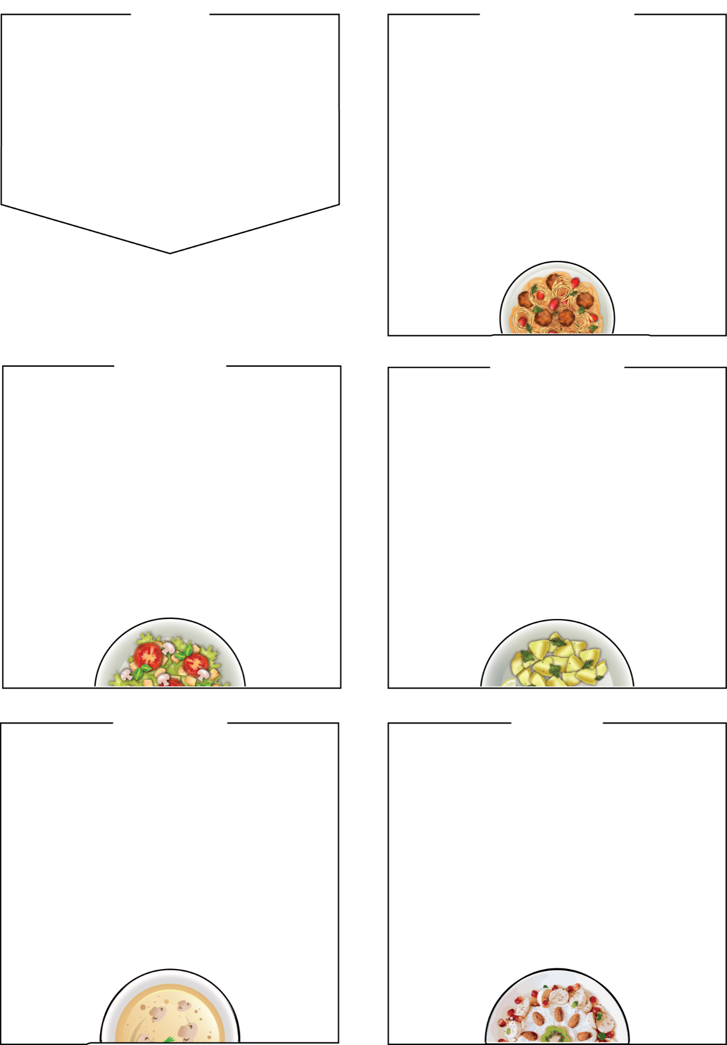



MENU
Bramingham Lunches
WEDNESDAY

Roast Chicken Dinner

Roast Quorn Dinner (Veg)

Jacket Potato with Cheese and Beans

Sides
roast dinner served with roast potatoes,

crispy Yorkshire pudding, seasonal vegetables, and stuffing
salad bar
Dessert
Shortbread cookie, yoghurt, fresh fruit

BRAMINGHAM PRIMARY SCHOOL

WEEK ONE

Week Commencing: 2nd November,
23rd November, 14th December

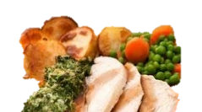

THURSDAY

Fresh Bread and Fruit Served Daily

.

Beef Lasagne
garlic bread, seasonal vegetables, or salad

Quorn Mince Bolognaise and Pasta (Veg)

Tomato sauce, garlic bread, seasonable veg

Jacket Potato Cheese & Beans or Tuna Mayo

Sides
garlic bread slice, salad bar, seasonal vegetables

Dessert
Jelly, yoghurt, fresh fruit

MONDAY

Cheese and Tomato Pasta Bake (Veg)

Quorn Meatballs and Pasta in

Tomato Sauce (Veg)

Asian Noodles (Veg)

Sides
garlic bread, salad bar, seasonal vegetables
Dessert
Marble chocolate and vanilla sponge, yoghurt, fresh fruit

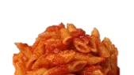
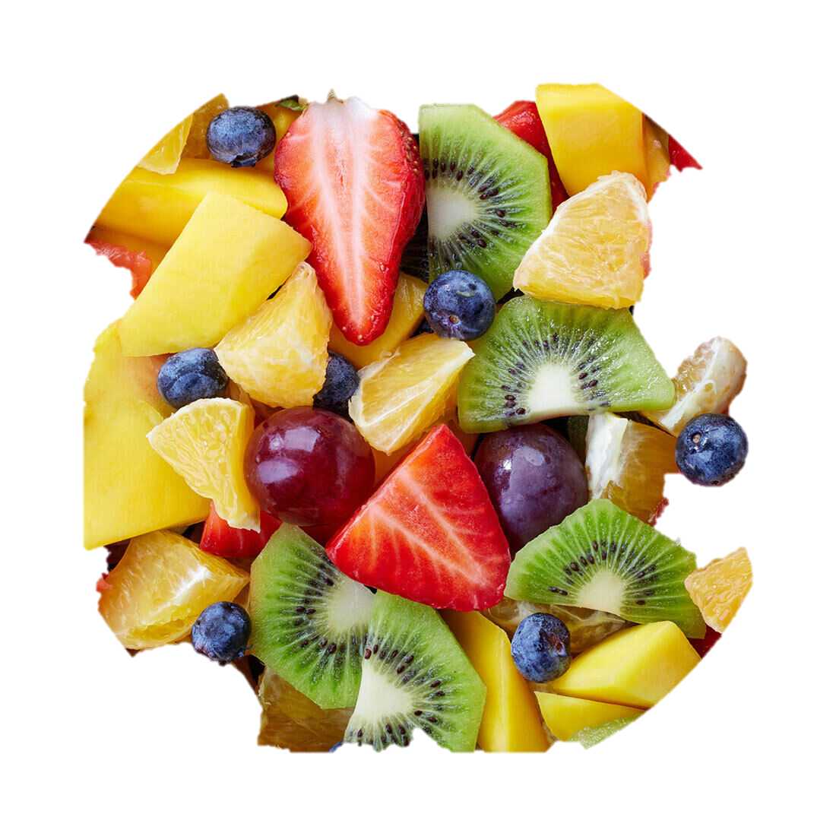


FRIDAY

Battered Cod Fillet

Chicken Nuggets (Halal)

Cheese Panini (Veg)
with French fries

Sides
french fries, baked beans or spaghetti hoops, peas, salad bar

Dessert
Ice cream tub, yoghurt, seasonal fresh fruit

TUESDAY

Chicken Curry and Rice (Halal)

Vegetable Curry and Rice (Veg)

Cream Cheese and Ham Bagel

Sides

naan bread, rice salad bar, seasonal veg

Dessert
apple crumble and custard, yoghurt,
fresh fruit

