# MENU

**Bramingham Lunches**

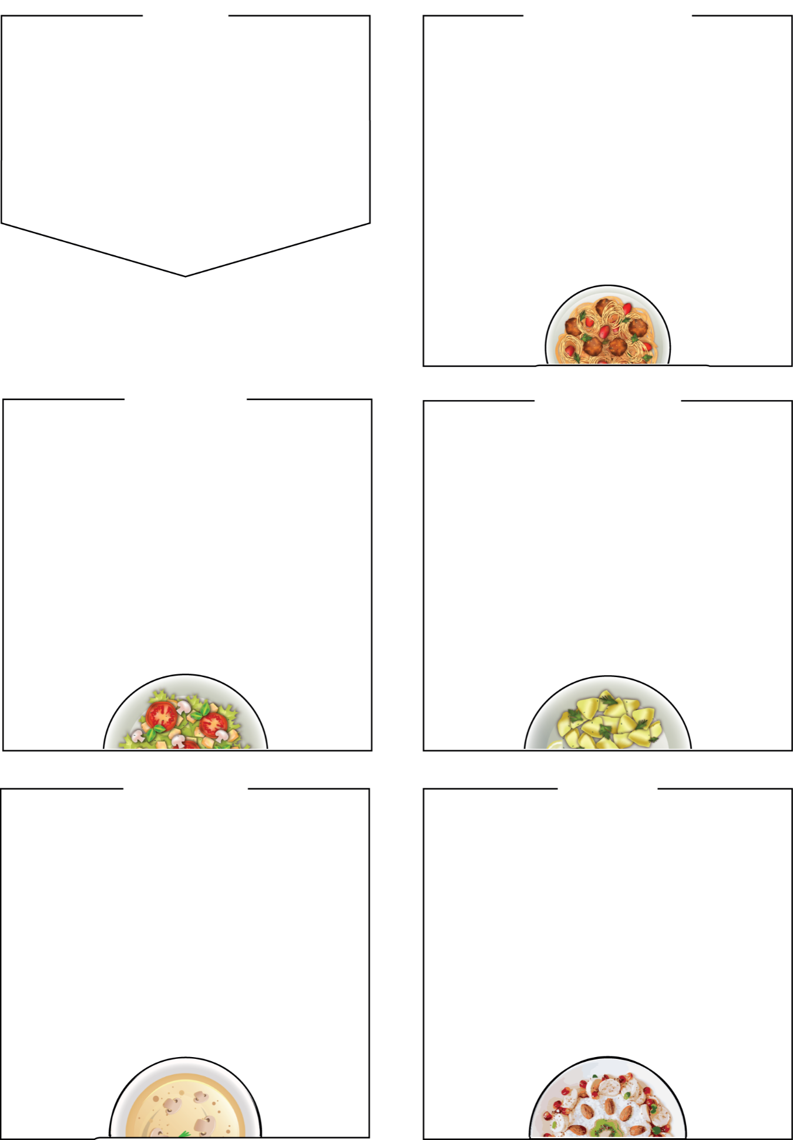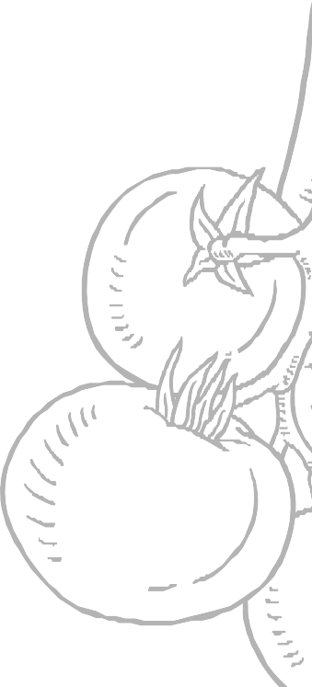

**WEDNESDAY**

## Roast Chicken Dinner

## Roast Quorn Dinner (Veg)

## Cheese Bagel and Fresh Snack Pot (Veg)

cheese filling, with a fresh veg snack pot

## Sides

Roast Dinner served with roast potatoes, Yorkshire pudding, stuffing and

seasonal vegetables, bread

**Dessert**

Jelly, yoghurt, fresh fruit bar

BRAMINGHAM PRIMARY SCHOOL

# WEEK ONE

**Week Commencing: Tuesday 7th January 28th January, 24th February,17th March**

# THURSDAY

**Fresh Snack Pots include a selection of fresh produce such as cucumber and carrot sticks, halved grapes, cherry tomatoes.**

# 

# MONDAY

# 

## Mac and Cheese (Veg)

Tasty cheesy macaroni with choice of garlic bread, seasonal vegetables, or salad

## Warm Chicken Wrap

Juicy chicken strips, lettuce, tomato, cucumber

## Jacket Potato Cheese & Beans (Veg)

## Sides

garlic bread slice, salad bar,

seasonal vegetables

## Dessert

Chocolate sponge and custard, yoghurt, fresh fruit bar

## Tomato Pasta Bake (Veg)

## Quorn Meatballs and Pasta (Veg)

## in a tasty tomato sauce, add a little cheese on top

## Jacket Potato, Cheese and Beans (Veg)

## Sides

garlic bread, salad bar, seasonal vegetables

**Dessert**

Shortbread cookie, yoghurt,

fresh fruit

# 

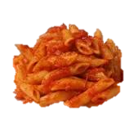

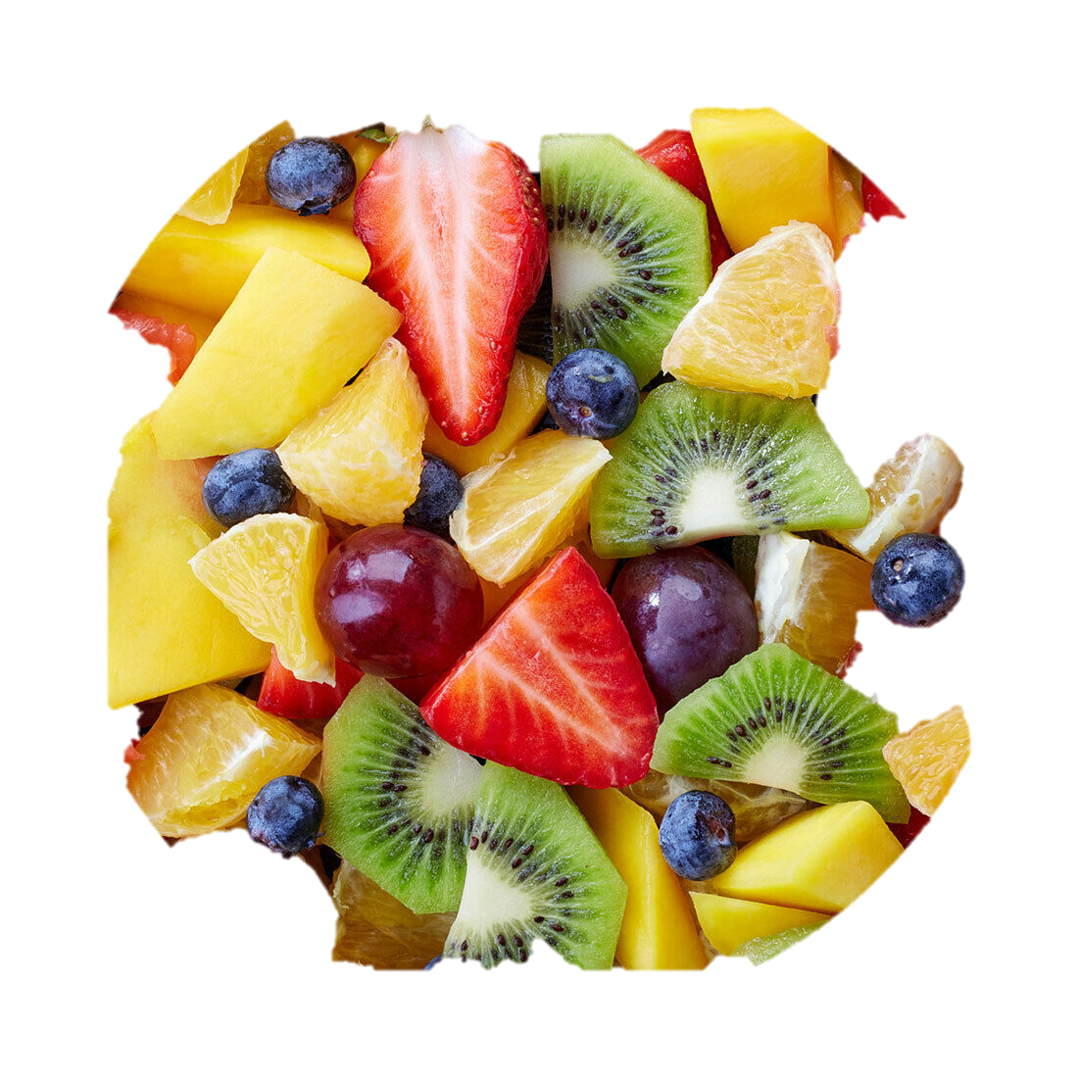

**Pork Sausages**

## Lamb Burger in a Bun (Halal)

## Asian Noodles (Veg)

egg Noodles, peppers, peas, spring onion, beansprouts in a tamari, ginger sauce

## Sides

## baked potato wedges, peas, sweetcorn, salad

## Dessert

Cornflake crispy cake, yoghurt, seasonal fresh fruit bar

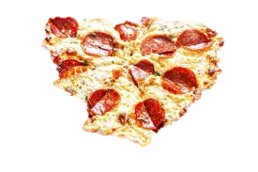

## It’s Pizza Friday

## Pepperoni Pizza

## Cheese and Tomato Pizza (Veg)

## Fishfingers

## Sides

french fries, baked beans, peas

**Dessert**

Ice cream tub, yoghurt, seasonal fresh fruit

**FRIDAY**

# TUESDAY

