# MENU

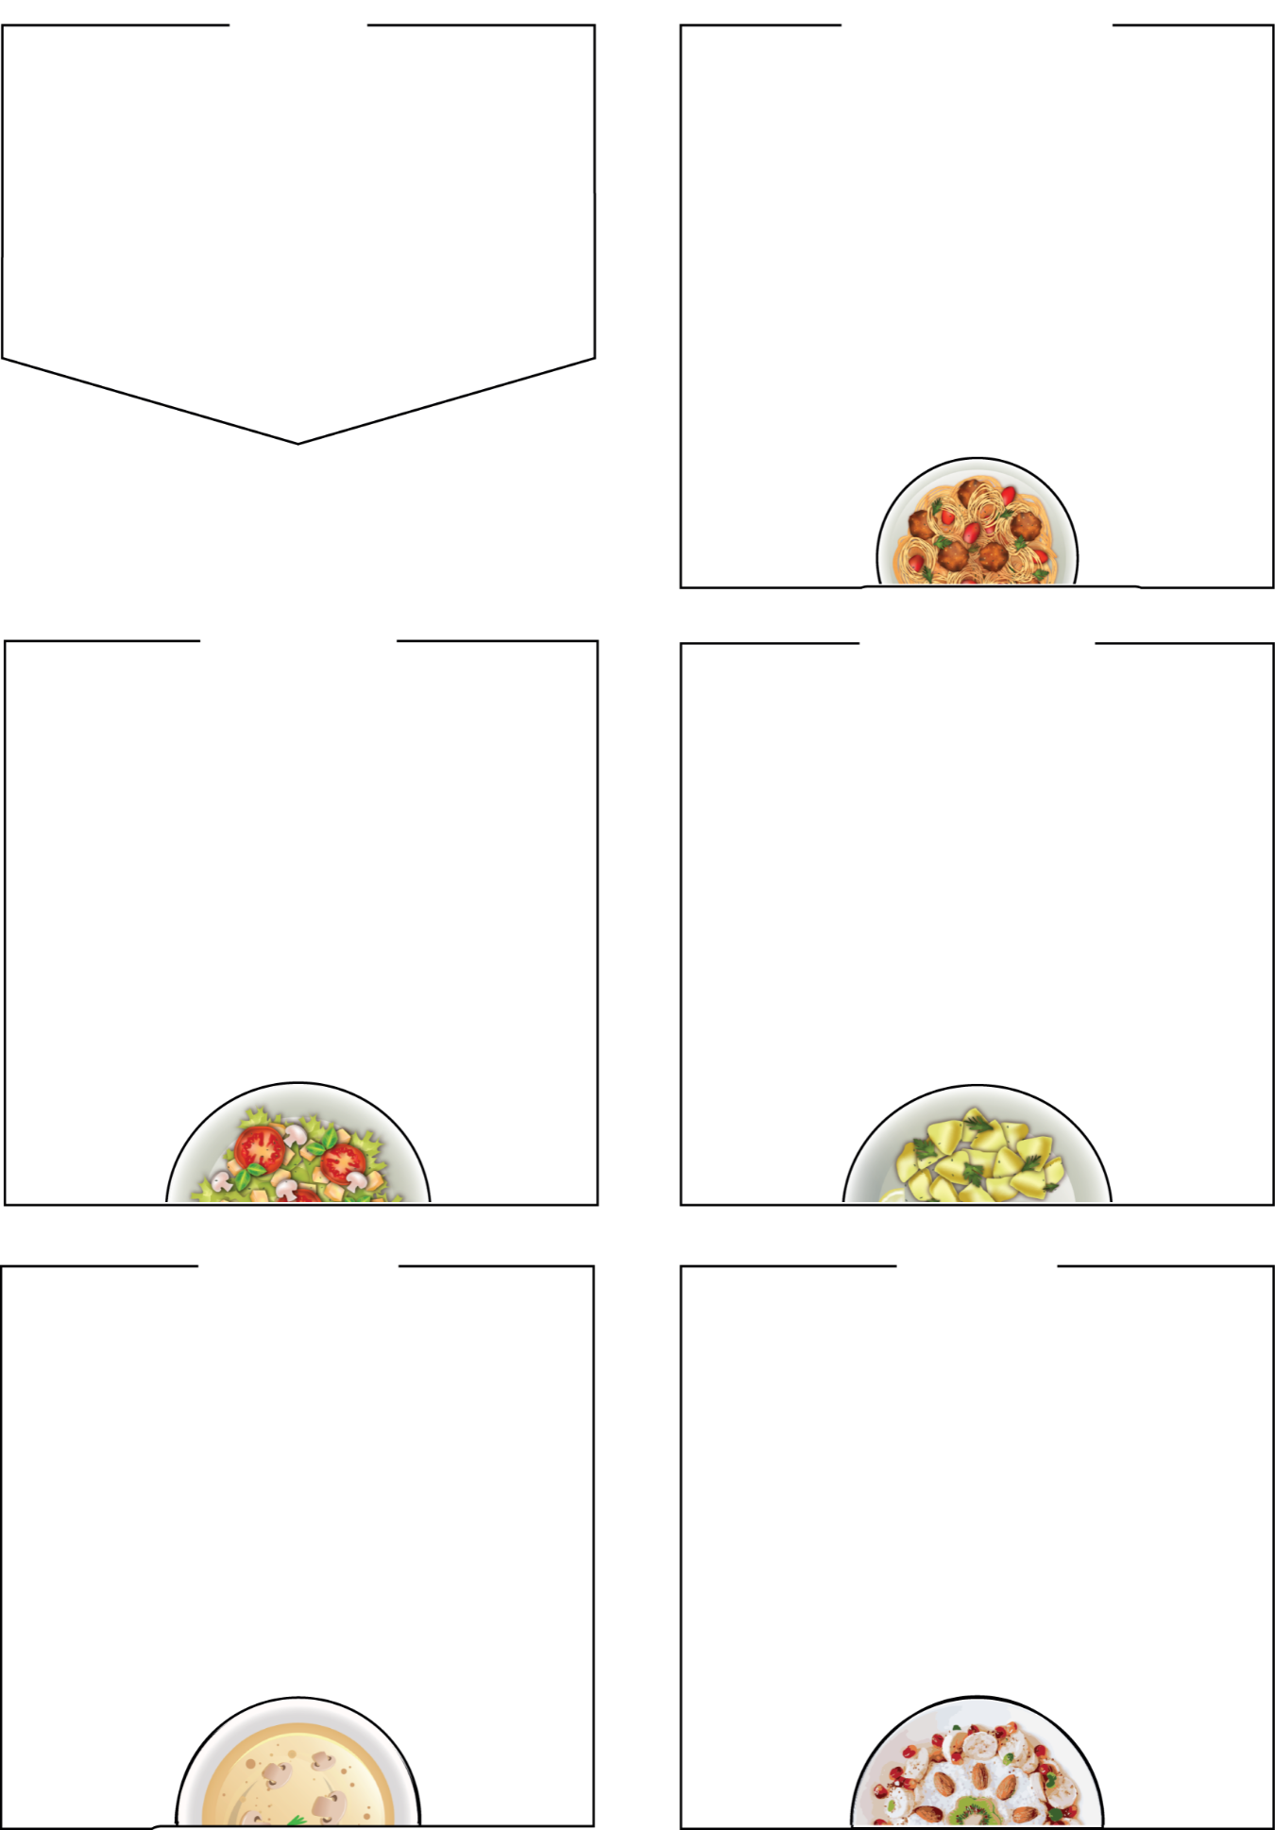

**Bramingham Lunches**

**WEDNESDAY**

## Roast Chicken Dinner

## Roast Quorn Dinner (Veg)

## Bagel (Veg)

cheese melt with Fresh Snack Pot/vegetables

## Sides

roast dinner served with roast potatoes,

## crispy Yorkshire pudding, seasonal vegetables, and stuffing

salad bar

**Dessert**

apple crumble & custard, yoghurt, fresh fruit

BRAMINGHAM PRIMARY SCHOOL

# WEEK THREE

**Week Commencing: 20th January,**

**10th February, 10th March, 31st March**

# THURSDAY

**Fresh Snack Pots include a selection of fresh produce such as cucumber and carrot sticks, halved grapes, cherry tomatoes.**

# 

## Beef Lasagne

garlic bread, seasonal vegetables, or salad

## Italian Veggie Pasta

## Tomato sauce, broccoli, garlic bread, seasonable veg

## Jacket Potato Cheese & Beans (Veg)

## Sides

garlic bread slice, salad bar, seasonal vegetables

## Dessert

jelly, yoghurt, fresh fruit

# MONDAY

# 

## Vegetable Curry (Veg)

## Asian Noodles (Veg)

## Cheese and Tomato pinwheel (Veg)

## Puff pastry with cheese on a tomato base

Salad snack pot / fresh veg

## Sides

naan bread, salad bar, seasonal vegetables

**Dessert**

marble chocolate and vanilla sponge, yoghurt, fresh fruit

# 

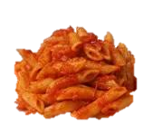

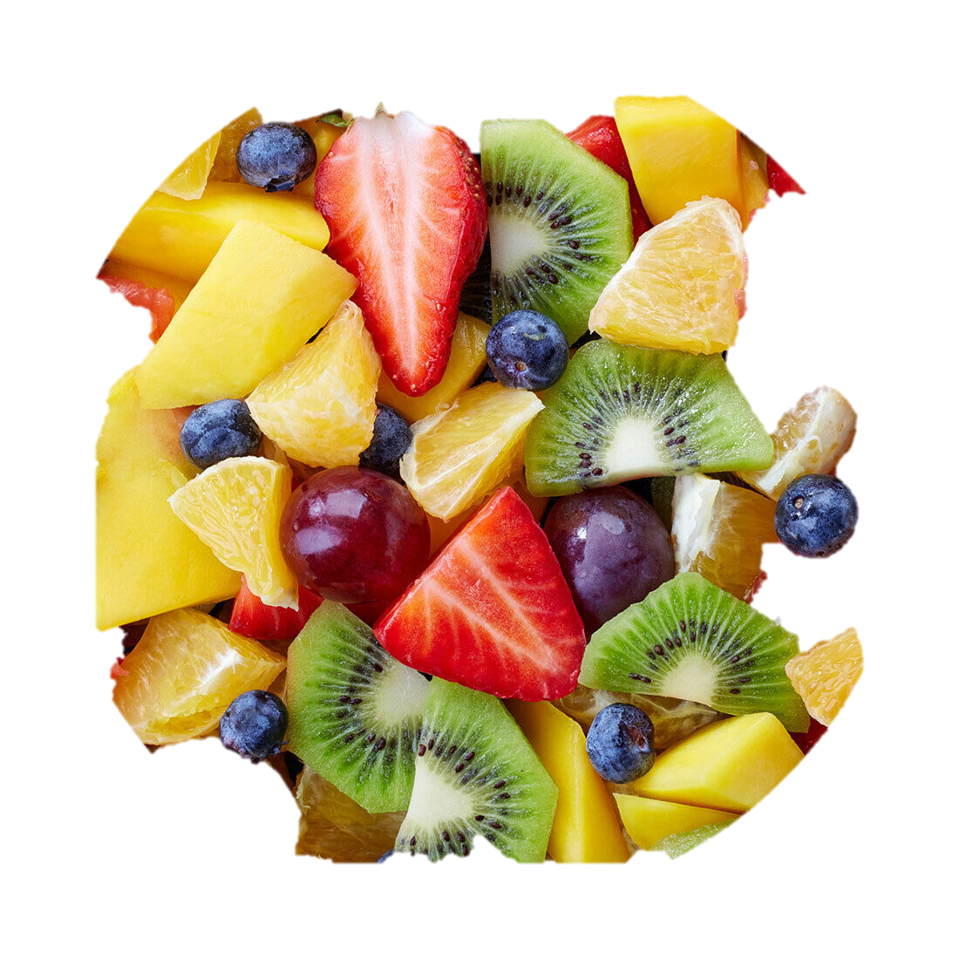

**Pork Sausages**

add potato wedges and seasonal vegetables

## Crispy Chicken Goujons (Halal)

## Jacket Potato Cheese & Beans

## Sides

## baked potato wedges, salad bar, seasonal veg

## Dessert

shortbread biscuit, yoghurt,

fresh fruit



## It’s Pizza Friday

## Cheese and Tomato Pizza (veg)

## Fish fingers and Chips

## Tuna Panini

tuna melt with Fresh Snack Pot/chips

## Sides

french fries, baked beans, peas, salad bar

**Dessert**

frozen chocolate mousse tub, yoghurt, seasonal fresh fruit

**FRIDAY**

# TUESDAY