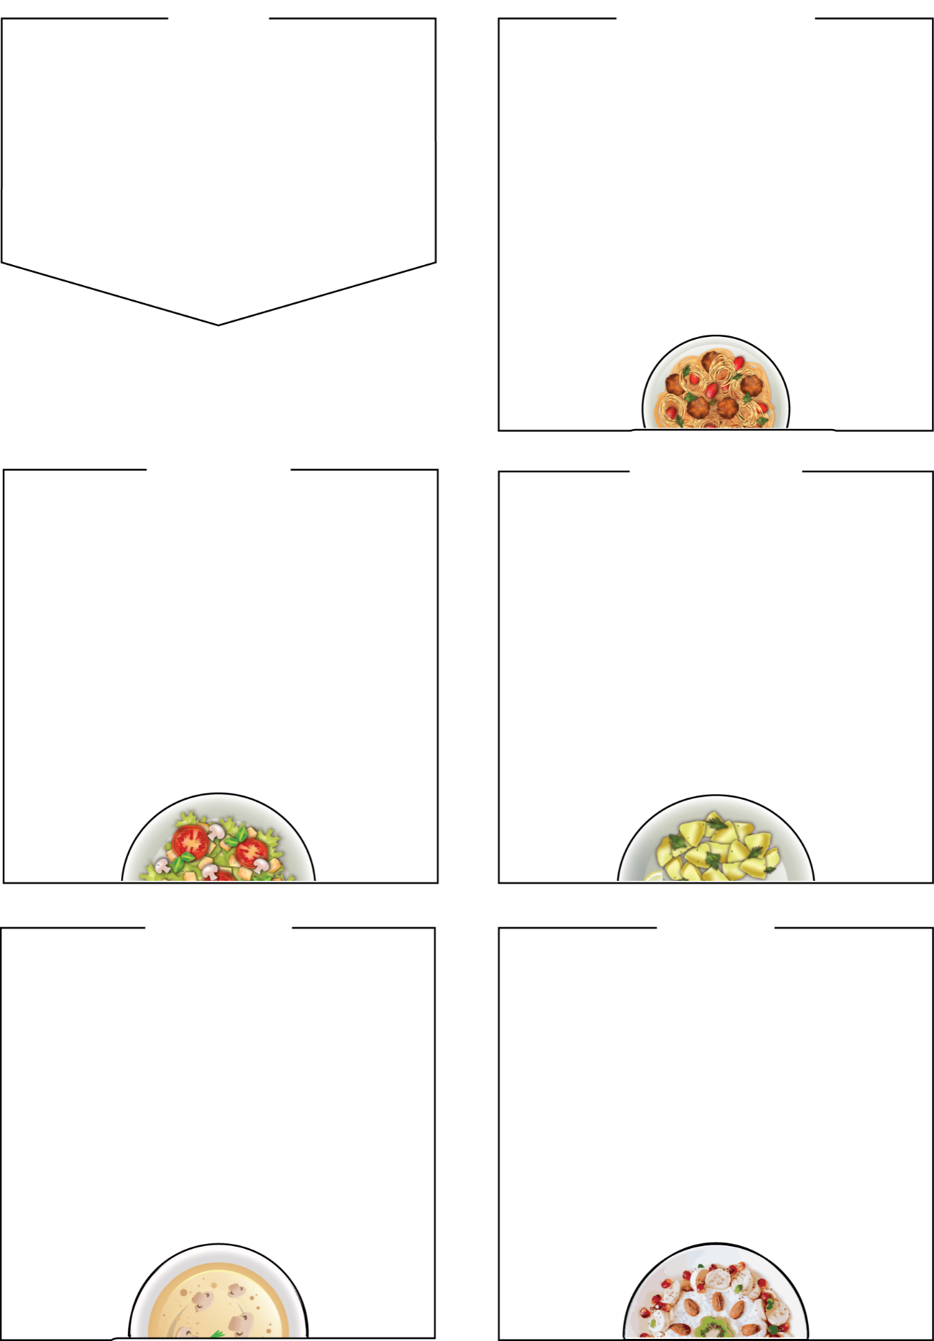



MENU
Bramingham Lunches
WEDNESDAY

Roast Pork Dinner

crispy yorkshire pudding, seasonal vegetables, and stuffing

Roast Quorn Dinner (Veg)

Jacket Potato with a choice of tuna mayo or cheese & beans

Sides
roast dinner served with roast potatoes and
seasonal vegetables, bread, salad bar
Dessert
Shortbread cookie, yoghurt, fresh fruit

BRAMINGHAM PRIMARY SCHOOL

WEEK TWO

Week Commencing: 09th November,
30th November

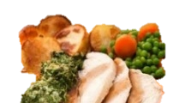

THURSDAY

Fresh Bread and Fruit served Daily.

(Halal) Chicken Pie and Mash

Cheese and Broccoli Pasta Bake (Veg)
A cheese sauce pasta,

Tuna Vegan-Mayo Bagel

Sides
mashed potato, salad bar, seasonal vegetables, bread

Dessert
Waffle and custard, chocolate sauce, yoghurt,
fresh fruit

MONDAY

Tomato Pasta Bake (Veg)

in a tasty tomato sauce, with cheese on top

Quorn Meatballs (Vegan)

in a tasty tomato sauce, with pasta

Jacket Potato with Cheese and Beans

Sides
garlic bread, salad bar, seasonal vegetables
Dessert
Apple sponge cake, yoghurt,
fresh fruit

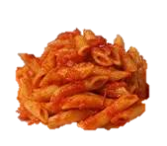

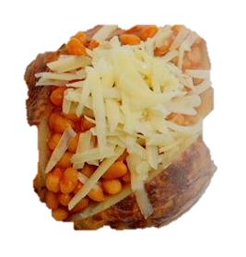

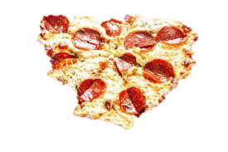
Cottage Pie

Served with seasonal vegetables

Chicken Goujons and wedges (Halal)

Panini (Veg)
cheese filling served with wedges and salad

Sides

baked potato wedges, salad bar, seasonal veg, bread

jelly and fruit, yoghurt, fresh fruit bar

TUESDAY

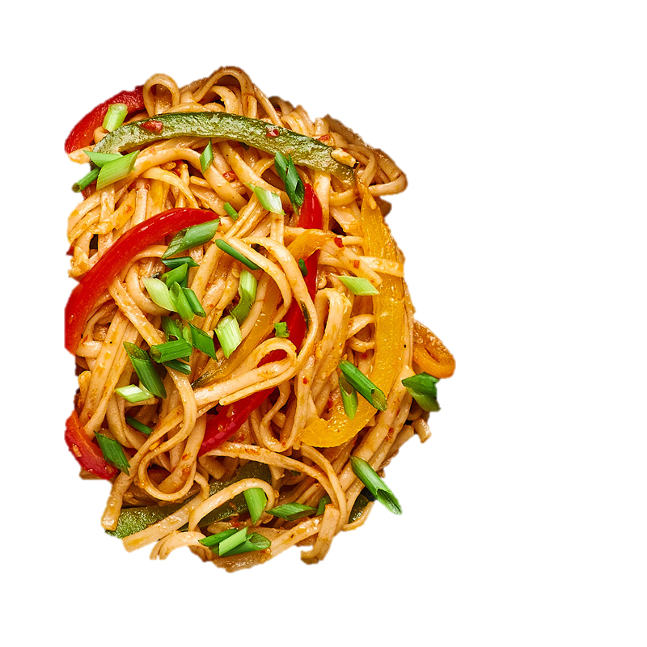

Cheese and Tomato Pizza (Veg)

Fishfingers

Pork Sausage Roll

Sides
french fries, baked beans, peas, salad bar

Dessert
Ice cream tub, yoghurt, seasonal fresh fruit

FRIDAY

