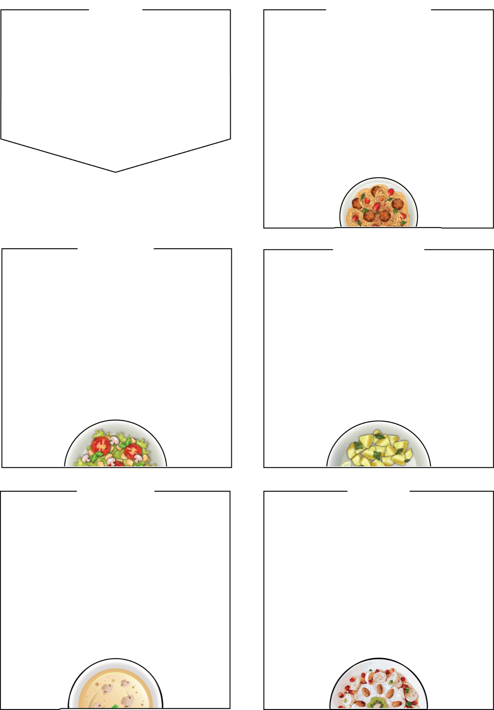



MENU
Bramingham Lunches
WEDNESDAY

Roast Chicken Dinner

Roast Quorn Dinner (Veg)

Veggie Pasty (Veg)

Sides
served with roast potatoes, Yorkshire pudding, stuffing and
seasonal vegetables, bread
Dessert
American pancake and fruit, yoghurt, fresh fruit

BRAMINGHAM PRIMARY SCHOOL

WEEK THREE
Week Commencing: 16th November,
7th December

THURSDAY

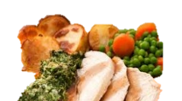

Mac and Cheese

served with garlic bread

Beef Wrap
Our popular minced beef wrap with cheese on top

Jacket Potato with a choice of tuna mayo or cheese & beans (Veg)

Sides
salad bar,
seasonal vegetables

Dessert
Chocolate sponge and custard yoghurt, fresh fruit bar

MONDAY

Vegan Sausage Roll and Potato Puffs (Veg)

Asian Noodles (Veg)

Jacket Potato, Cheese and Beans (Veg)

Sides
Bread, salad bar, seasonal vegetables, baked beans
Dessert
Yoghurt, Fresh fruit Salad

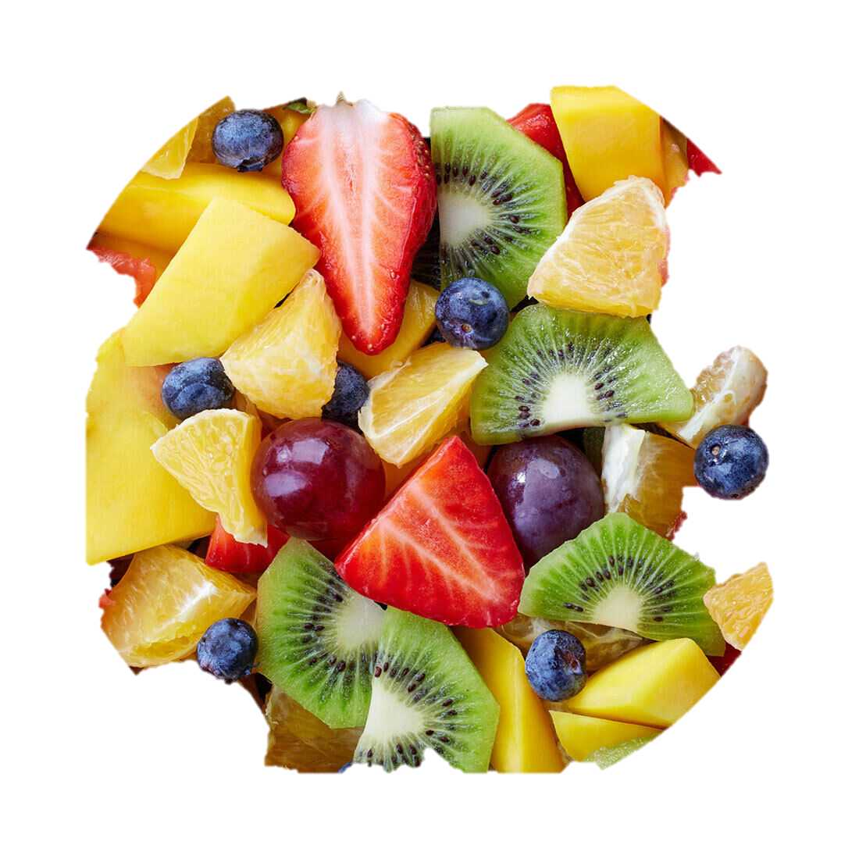

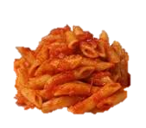
Sausage Pasta Bake
(tomato based pasta sauce)

Hot Chicken Wrap (Halal)

Tomato Pasta (Veg)

Sides

Garlic Bread, Seasonal vegetables, salad

Dessert
Jelly and fruit, yoghurt, seasonal fresh fruit

TUESDAY

It’s Pizza Friday

Pepperoni Pizza

Cheese and Tomato Pizza (Veg)

Fishfingers

Minced white fish and potato fish shapes

Sides
french fries, baked beans, peas

Dessert
Ice cream tub, yoghurt, seasonal fresh fruit

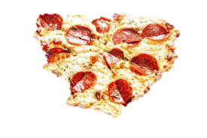

FRIDAY

