# MENU

**Bramingham Lunches**

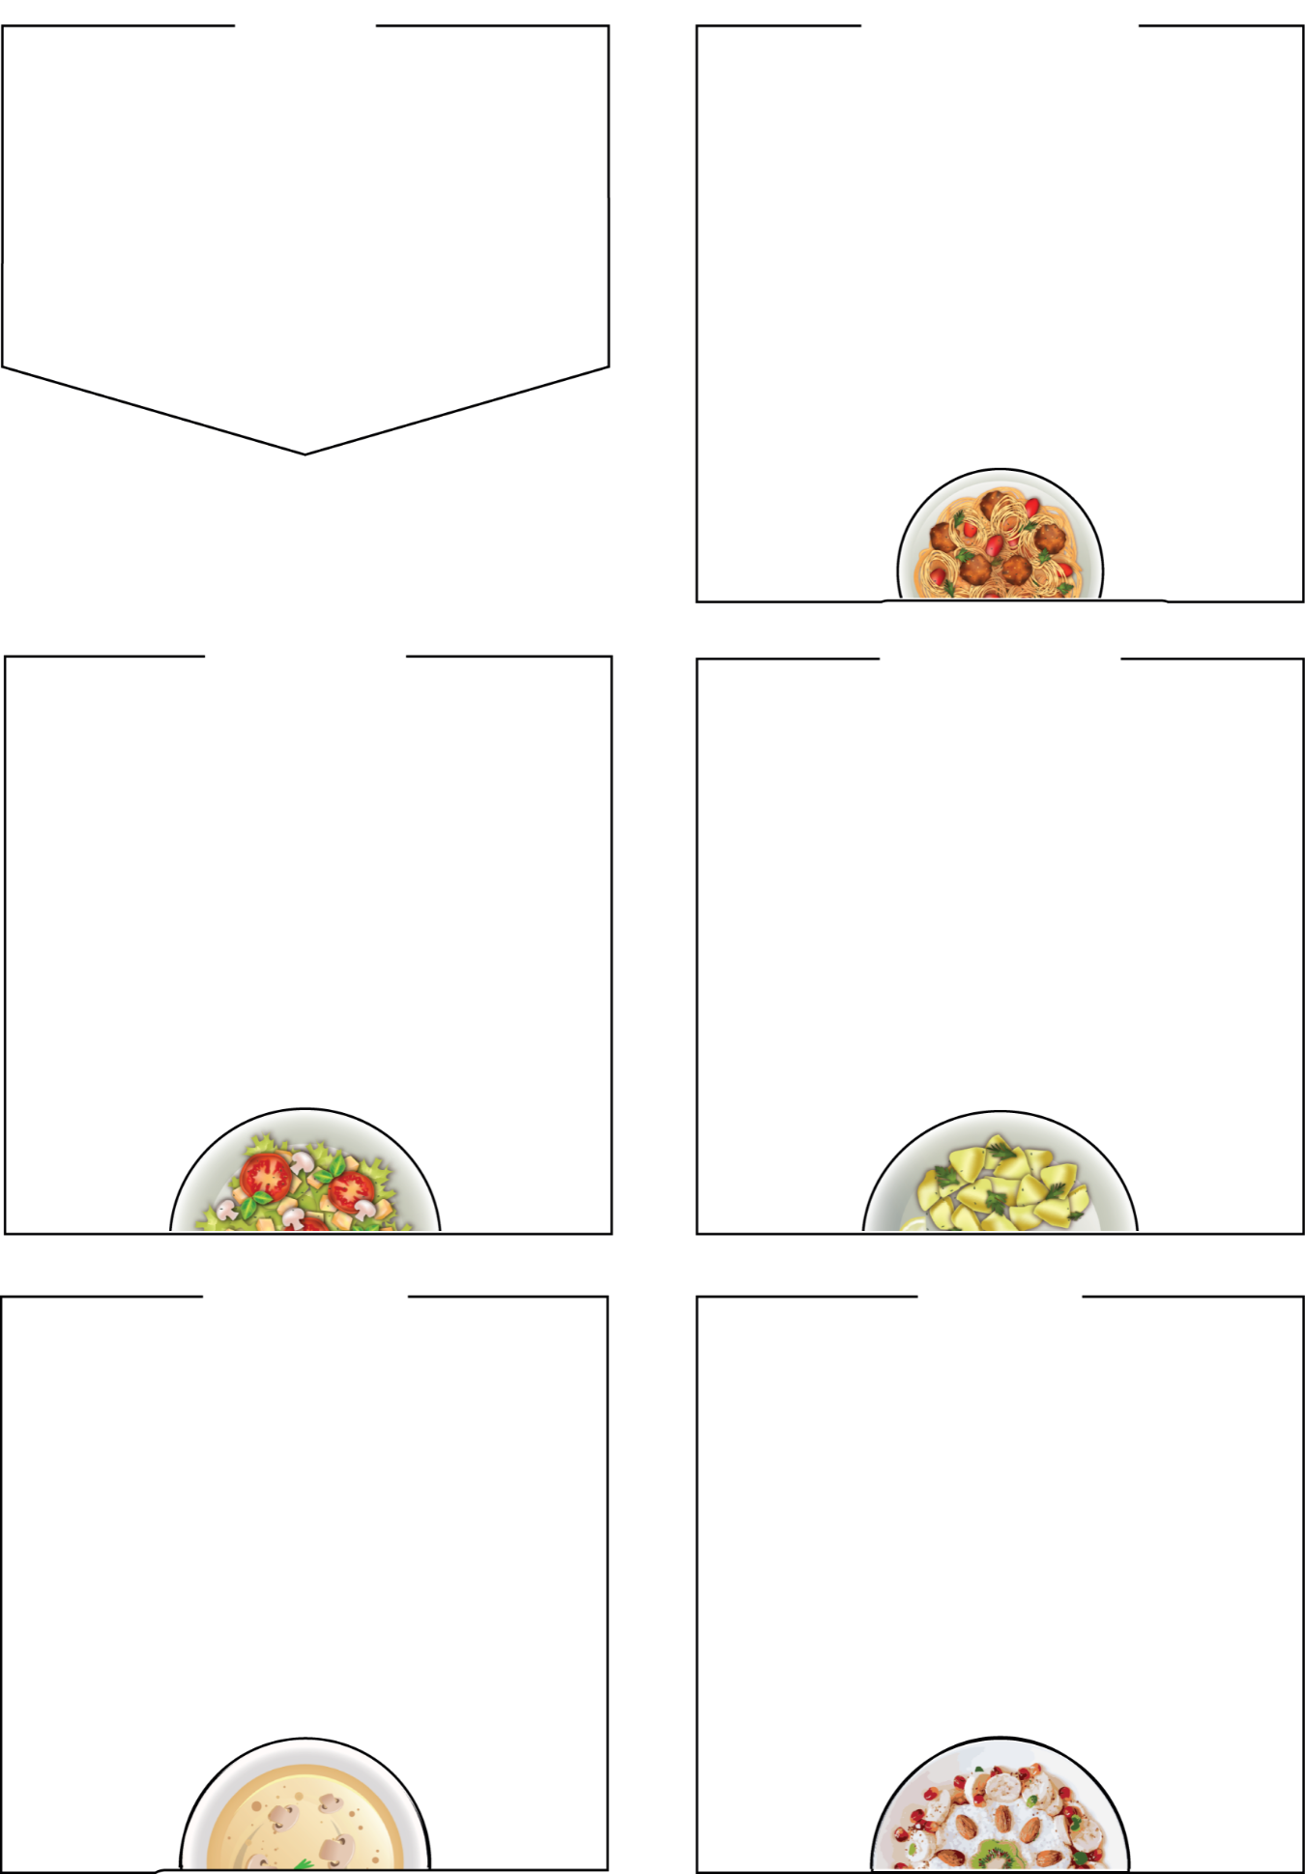

**WEDNESDAY**

## Roast Pork Dinner

## crispy yorkshire pudding, seasonal vegetables, and stuffing

## Roast Quorn Dinner (Veg)

## Veggie Pasty (Veg Option)

with Fresh Snack Pot and/or seasonal veg

## Sides

roast dinner served with roast potatoes and

seasonal vegetables, bread, salad bar

**Dessert**

Jelly with fruit side, yoghurt, fresh fruit

BRAMINGHAM PRIMARY SCHOOL

# WEEK TWO

**Week Commencing: 13th January,**

**3rd February, 3rd March,**

**24th March**

# THURSDAY

**Fresh Snack Pots include a selection of fresh produce such as cucumber and carrot sticks, halved grapes, cherry tomatoes.**

# 

# MONDAY

# 

## 

## Chicken Curry (Halal)

## Served with rice

## Beef Chilli Taco

A mild chilli served with a choice of salad,

cheese in a tortilla

## Jacket Potato Cheese & Beans

## Sides

naan bread rice, salad bar, seasonal vegetables

## Dessert

Waffle, chocolate sauce, yoghurt,

fresh fruit

## 

## Tomato Pasta Bake (Veg)

## in a tasty tomato sauce, with cheese on top

## Quorn Mince Bolognaise (Veg)

## in a tasty tomato sauce, with spaghetti

## Jacket Potato with Cheese and Beans

## Sides

garlic bread, salad bar, seasonal vegetables

**Dessert**

Apple sponge cake, yoghurt,

fresh fruit

# 

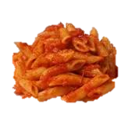

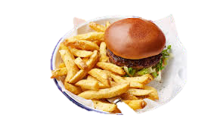

**Chicken Pie**

add mash and seasonal vegetables

## Chicken Style Noodles (Veg)

Quorn and egg noodles with a choice of sides

## Panini and Fresh Snack Pot (Veg)

cheese filling, with a fresh veg snack pot

## Sides

## Mashed potato, salad bar, seasonal veg, bread

## Dessert

shortbread cookie, yoghurt, fresh fruit bar

## Beef Burger in a Bun

## Fish Sea Stars

## Quorn Burger in a Bun

## Sides

french fries, baked beans, peas, salad bar

**Dessert**

Ice cream tub, yoghurt, seasonal fresh fruit

**FRIDAY**

# TUESDAY