20th November 2023

Dear Parents,

We would like to invite you to our Key Stage 1 Nativity performance. There will be two performances on Tuesday, 12th December at 9.30am and on Tuesday, 12th December at 2.30pm.

We have a limited number of seats for each performance, so please click on the link to book your seats. We will allocate up to 2 seats per family and if we have any spare tickets, we will inform you once all families have had the opportunity to book.

Please click on the link below to book your seats by Monday 27th November:

Tuesday 12th December at 9.30am https://forms.office.com/e/2Lku6mBES2

Tuesday 12th December at 2.30pm https://forms.office.com/e/k44X5VTXtC

We look forward to seeing you.

Yours sincerely

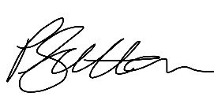
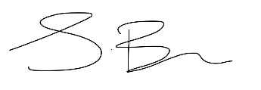

Mrs S Bains and Miss P Sutton
Co- Headteachers

