 | EYFS | Year 1 | Year 2 | Year 3 | Year 4 | Year 5 | Year 6
Autumn 1 | Art and Design is embedded in the EYFS curriculum, primarily within ‘Expressive Arts and Design’. The children are given a wealth of opportunities to engage in activities, both child-initiated and adult-directed, which enable them to experiment with a range of media and materials to mark make, model and construct.  -Safely use and explore a variety of materials, tools and techniques, experimenting with colour, design, texture, form and function.  - Share their creations, explaining the process they have used. | What is a sketchbook used for?  Drawing  Using drawing, collage and mark-making to create a collaborative class work of art linked to spirals  Introducing sketchbooks  Using nature to develop drawing skills by exploring types of lines and types of media. To create a spiral/circle using pencil and dry media to form a collaborative class work  Artist: Kandinsky and Molly Haslund  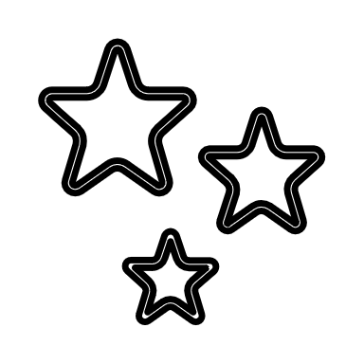 | How do different artists draw and paint flowers?  Drawing and painting  Still life observational painting of flowers/plants  Looking at Still life (flowers and plants) and developing understanding of colour using poster paints  Artists: Vincent Van Gogh and Georgia O’Keefe  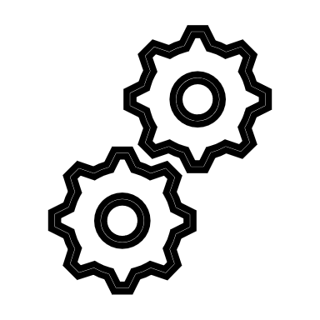 |  |  | What images/ shapes/ patterns could you use to ‘tell’ the poem?  Printing  Create a poetry zine using printing (carbon paper) and collage.  Combining monotype printing with painting and collage to create a visual poetry zine.  Artists: Kevork Mourad | How have the different artists shown light, water and reflection in their paintings?  Painting  Watercolour painting linked to light, water and reflection.  Observing and representing light, water and reflection using watercolour painting techniques.  Artists: Claude Monet, Japanese artwork and  David Hockney
Autumn 2 |  |  | What is meant by ‘print’? How can we make simple prints?  Printing  Nature themed Mono-printing using polystyrene tile  Exploring simple ways to print resulting in designing and a simple nature themed, e.g. leaf print, polystyrene tile. To use print to create a collaborative class artwork.  Artist: William Morris | How can we use our knowledge of colour and shape to create a successful Op Art picture?  Drawing and painting  Using colour to create op-art.  Exploring the colour wheel, shape and pattern through Op Art  Artist: Bridget Riley and Frank Stella | How can we create texture, form and pattern using clay?  Sculpture  Creating a clay tile  Exploring clay techniques to create a themed clay tile (possibly Egyptian eye)  Artist: Mahmoud Mukhtar  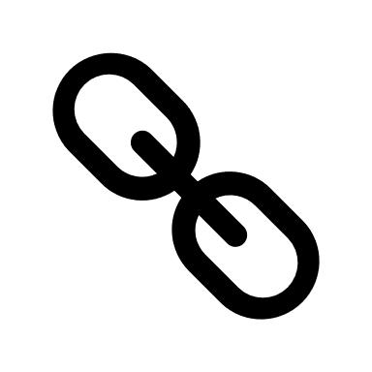 |  | What do you think the sculpture represents? Why?  Sculpture  Creating an abstract clay sculpture  Designing and sculpting (from clay) natural forms inspired by a modern sculptor.  Artists: Henry Moore and  Barbara Hepworth
Spring 1 |  | How do artists use colour in their work?  Painting and colour  Exploring colour – create painting linked to seasons  Exploring colour, pattern, shape and brush size in painting – producing work inspired by famous artists.  Name basic colours and make tints. Know primary colours. Mix simple colours. Paint using poster or powder paints.  Artists: Jackson Pollock and Joan Mitchell, Piet Mondrian |  | How is art used in storytelling?  Drawing and painting  Create a book illustration (watercolours and ink)  Using watercolours (background washes) and line drawings to create an illustration for a chosen book  Artists: Charlie Mackesy, Laura Carlin and Shaun Tan | How do you think the artists have created their prints?  Printing  Seacape inspired printmaking – relief tile  Investigating printing techniques, including the layering of colour and creation of a relief tile. To create a seascape inspired print (for class mural).  Artist: Katsushika Hokusai and James Bartholomew  Other printmakers: Michell Hughes and Alison Deegan
Spring 2 |  |  | How can we make a 3D object (pot) from clay?  Sculpture  African design clay pot  Exploring clay and learning techniques to create a pot inspired by African art.  Artist: Esther Mahlangu | How do different artists represent the human form?  Sculpture and drawing  Sculpture exploring human form  Exploring the human form resulting in creating a wire and foil sculpture  Main artist: Alberto Giacometti (main)  Other: Anthony Gormley, Niki de Saint Phalle |  |  | How can we draw a face accurately? What things could you draw to represent you?  Drawing and multimedia  Exploring identity using mixed media  Exploring accurate representations of faces to produce a mixed-media self-portrait which represents them.  Artists: Leonardo da Vinci, Kelvin Okafor
Summer 1 |  | What is meant by a collage? How will you make your portrait?  Collage (including digital)  Produce a portrait collage by layering materials  Exploring the use of layering materials and using different media to produce a portrait collage  Artists: Henri Matisse and Paul Klee |  |  | What is meant by composition and how do artists use it in still life?  Drawing and painting  Creating own composition using watercolours and viewfinders.  Exploring landscape/still life and creating own composition. Using viewfinder/photography to capture best angle to create own still-life inspired artwork  Artist: Paul Cezanne, , Jan Davidsz and Hilary Pecis, | How can perspective be used to draw buildings accurately?  Drawing  Drawing architecture  Draw accurately for extended periods to produce detailed, analytical drawings  Exploring one-point perspective (using a vanishing point) when drawing architecture. Developing understanding of architecture design and change over time.  Artist: Stephen Wiltshire, Zaha Hadid and Antoni Gaudi
Summer 2 |  |  |  |  |  | What are the main characteristics and features of Pop Art?  Digital media  Pop art inspired artwork – mixed media  Exploring pop-art and digital techniques to create own inspired artwork.  Artists: Andy Warhol and Roy Lichtenstein

Key
 | Build – area of study that builds on previous area of learning |  | Revisit – spaced retrieval
 | Link – area of study links to another curriculum area |  | New - Introduce new content

