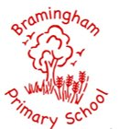

EYFS in Action
Every individual, every achievement, and every moment matters

EYFS Curriculum at Bramingham Primary School

During the Reception year the Early Years Foundation Stage Framework is followed; this was revised in 2021. The EYFS framework is a statutory requirement that lays out the standards the children in the early years should achieve. Assessments are made against it. Using the revised framework, a flexible Curriculum was written for children living in our community. Our curriculum sets out how we implement experiences and activities for children and how we monitor their impact.

The Framework is organised into seven areas of learning and development. These are then split into 3 prime areas and 4 specific areas. Each of the areas has Early Learning Goals that children are expected to achieve by the end of their Reception year in school.

The seven main areas of learning

The Prime Areas:
Personal, Social and Emotional Development (PSED)
Communication and Language (CL)
Physical Development (PD)

The Specific Areas:
Literacy (L)
Mathematics (M)
Understanding the World (UW)
Expressive Art (EAD)

All areas of learning are linked and connected.

Characteristics of Effective Learning
Children will be learning

Playing and exploring  children investigate and experience things, and ‘have a go’ | Active learning  children concentrate and keep on trying if they encounter difficulties, and enjoy achievements | Creating and thinking critically  children have and develop their own ideas, make links between ideas, and develop strategies for doing things
I can recognise that my actions have an effect on the world, so I like to repeat them.  I can guide my own thinking and actions by talking to myself as I play.  I can make independent choices.  I can plan and think ahead about how I will play with objects.  I can bring my own interests and fascinations into early years settings.  I can respond to new experiences when they are brought to my attention. | I can keep trying when things are difficult.  I can begin to connect my mistakes.  I can participate in routines.  I can begin to predict sequences because I know routines.  I can show goal-directed behaviour. | I can take part in simple pretend play.  I can sort materials.  I can review my progress as I try to achieve a goal and check how well I am doing.  I can feel confident about coming up with my own ideas.  I can solve real problems.  I can use pretend play to think beyond the ‘here and now’ and to understand another perspective.  I can concentrate on achieving something that is important to me.  I can make more links between my ideas.

Personal Social and Emotional Development (PSED) in Action
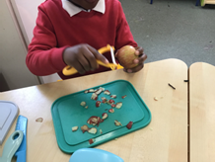
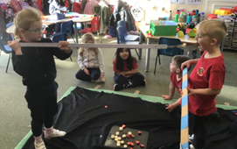
Daily routines to support positive behaviour.

Visual timetable

Promote independence, for example having snack and access to cut and peel their fruit.

Positive reinforcement of expected behaviour, including Epraise points

Specific taught sessions on emotions and feelings using the Jigsaw scheme, as well as sessions on keeping safe online, NSPCC pants rules and whole school Values

Parental involvement, stay and play sessions, home visit, parents invited to watch performance and share learning journals.

Children make choices about own friendship group and who to sit with at lunchtime etc, whilst also being encouraged to play with others.

Children vote for the daily story and take turns for their name to picked to choose the rhyme for rhyme time.

Adults encourage children to express their feelings if they are hurt or upset.

Weekly celebration for ‘Squirrel of the Week’, ‘Mathemagican’. ‘Top doodler’ and ‘Fab Writer’. Half termly celebration for ‘Values role model’

Children are also encouraged to share awards they achieve out of school.

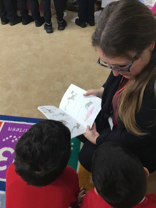
Calm down/quiet room for children to access in provision.

Sensory room onsite

Miss Legg and Mrs Altaf our family support workers for children or parents who need additional support.

Use of social stories, Bucket time and individual routines and charts for children who need additional support.
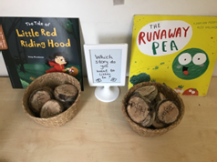
Communication and Language (CL) in Action

All children are screened using NELLI Assessment, children are identified for targeted intervention.

Children are targeted for Bucket time intervention.
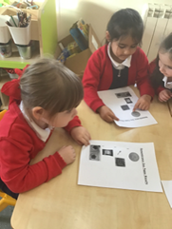
‘5 a day’ Literacy opportunities

Adults modelling questioning and conversation.

Quality, vocabulary rich, fiction and non-fiction texts used for taught sessions and story times.

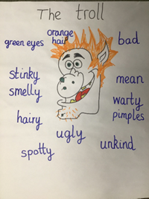
Learn rhymes, poems and songs to develop vocabulary.

Join in when a peer picks a rhyme in daily rhyme time.

To progress towards our core skill ‘To engage in a two-way conversation’.

Observed interaction between peers and remodelling of sentences to support.
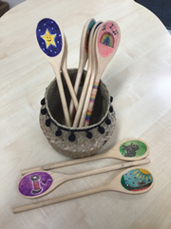
Daily carpet sessions for attentive listening

Daily story time, including children voting for the story they want to hear after lunch.

Use of talk partners to encourage sharing ideas leading into small group/whole class discussions.

Adults modelling complete sentences and accurate grammar.

Adults begin to use whole school strategies for questioning, such as ‘123 show’ me & ‘think, pair, share’.

Adults ask open ended questions.

Adults use ‘no hands up’ approach in line with whole school techniques and scaffold questions.

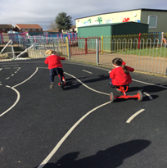
Physical Development (PD) in Action

Daily access to outdoor and indoor provision which includes opportunities for gross motor play i.e. climbing frame, bikes, scooters, large bricks, tyres, balance beams, wooden planks, hoops, dens building equipment, water wall, mud kitchen, bats and balls, bean bags and more.

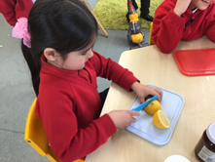
Daily access to outdoor and indoor provision which includes opportunities for fine motor play through for example, painting, drawing, scissors, playdough, chalk, pegs, colouring, threading, jigsaws, construction, water play etc.
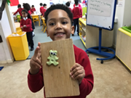
Daily ‘Busy fingers’ sessions to develop fine motor skills.

Weekly timetabled PE sessions to focus on specific skills.

Regular physical activity/brain break sessions using resources such as Jack Hartmann, Just dance, Go Noodle an Cosmic Yoga etc throughout the day.
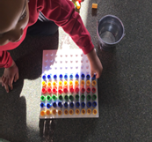
Children expected and supported to eat school dinner with a knife and fork and drink milk.

Children have access to safety knives and peelers to prepare their own fruit at snack time and access to open cups for water.

Pencil grip continuously monitored and children supported to move onto the next stage of progression when ready.

Children use Essential letters and sounds flashcards and rhymes to support correct letter formation for Phonics and all writing.

Provision of both left and right handed scissors, including dual control and easy grip scissors.

Use of sensory resources to encourage mark making in various ways i.e. shaving foam, sand, glitter, paint,
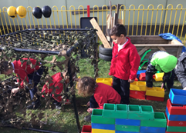
printing, chalkboards etc.
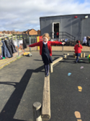
To progress towards our core skill ‘To perform to an audience’.

To progress towards our core skill ‘To make a woodwork model’.

To progress towards our core skill ‘To follow a recipe’.

Wake up walk

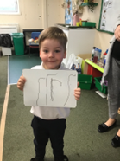
Literacy (L) in action
Daily Phonics sessions following Essential Letters and sounds. ‘5 a day Literacy’ opportunities.

Regular phonics assessment/tracking to ensure children are working at the correct phase and to address gaps.

Parents in Reception invited to a Phonics meeting in first half term to ensure they are aware of how we teach reading and writing and how they can support at home.

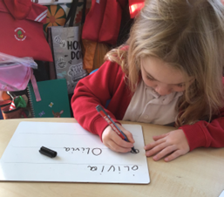
Daily rhyme times, including children taking turns to pick the rhyme. Daily story time, including children voting daily for the story they want to hear after lunch.

Frequent shared and modelled reading and writing in Literacy carpet sessions.

Comprehension taught during carpet sessions and when hearing individual readers (at least once a week).

Core texts used as focus for Literacy sessions. Talk for writing texts used to support language development and children’s oracy.

Quality, vocabulary rich, fiction and non-fiction texts used for taught sessions and daily story times, including use of Pie Corbett’s reading spine.

A varied selection of diverse fiction and non-fiction picture books in the provision.

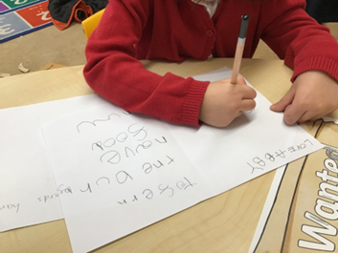
Phonetically decodable reading scheme books for the children to practise and consolidate their phonics knowledge.

Wordless books sent home as required to support book skills and storytelling.

Grapheme mats and visuals, always including tricky words available in the provision.

Meaningful reasons and opportunities for the children to read and write for a purpose.

Daily opportunities for oral blending and segmenting. Varied daily writing/writing skill opportunities in provision.

Continuous provision includes resources such as notebooks, envelopes, post it notes, whiteboards etc.

Half termly independent writing activity for Whole school assessed writing books. Writing recorded regularly in Learning Journals.

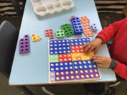
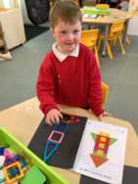
Maths (M) in Action

Planned and sequenced daily Maths lessons following NCETM for number and White Rose for Shape, space and Measures.
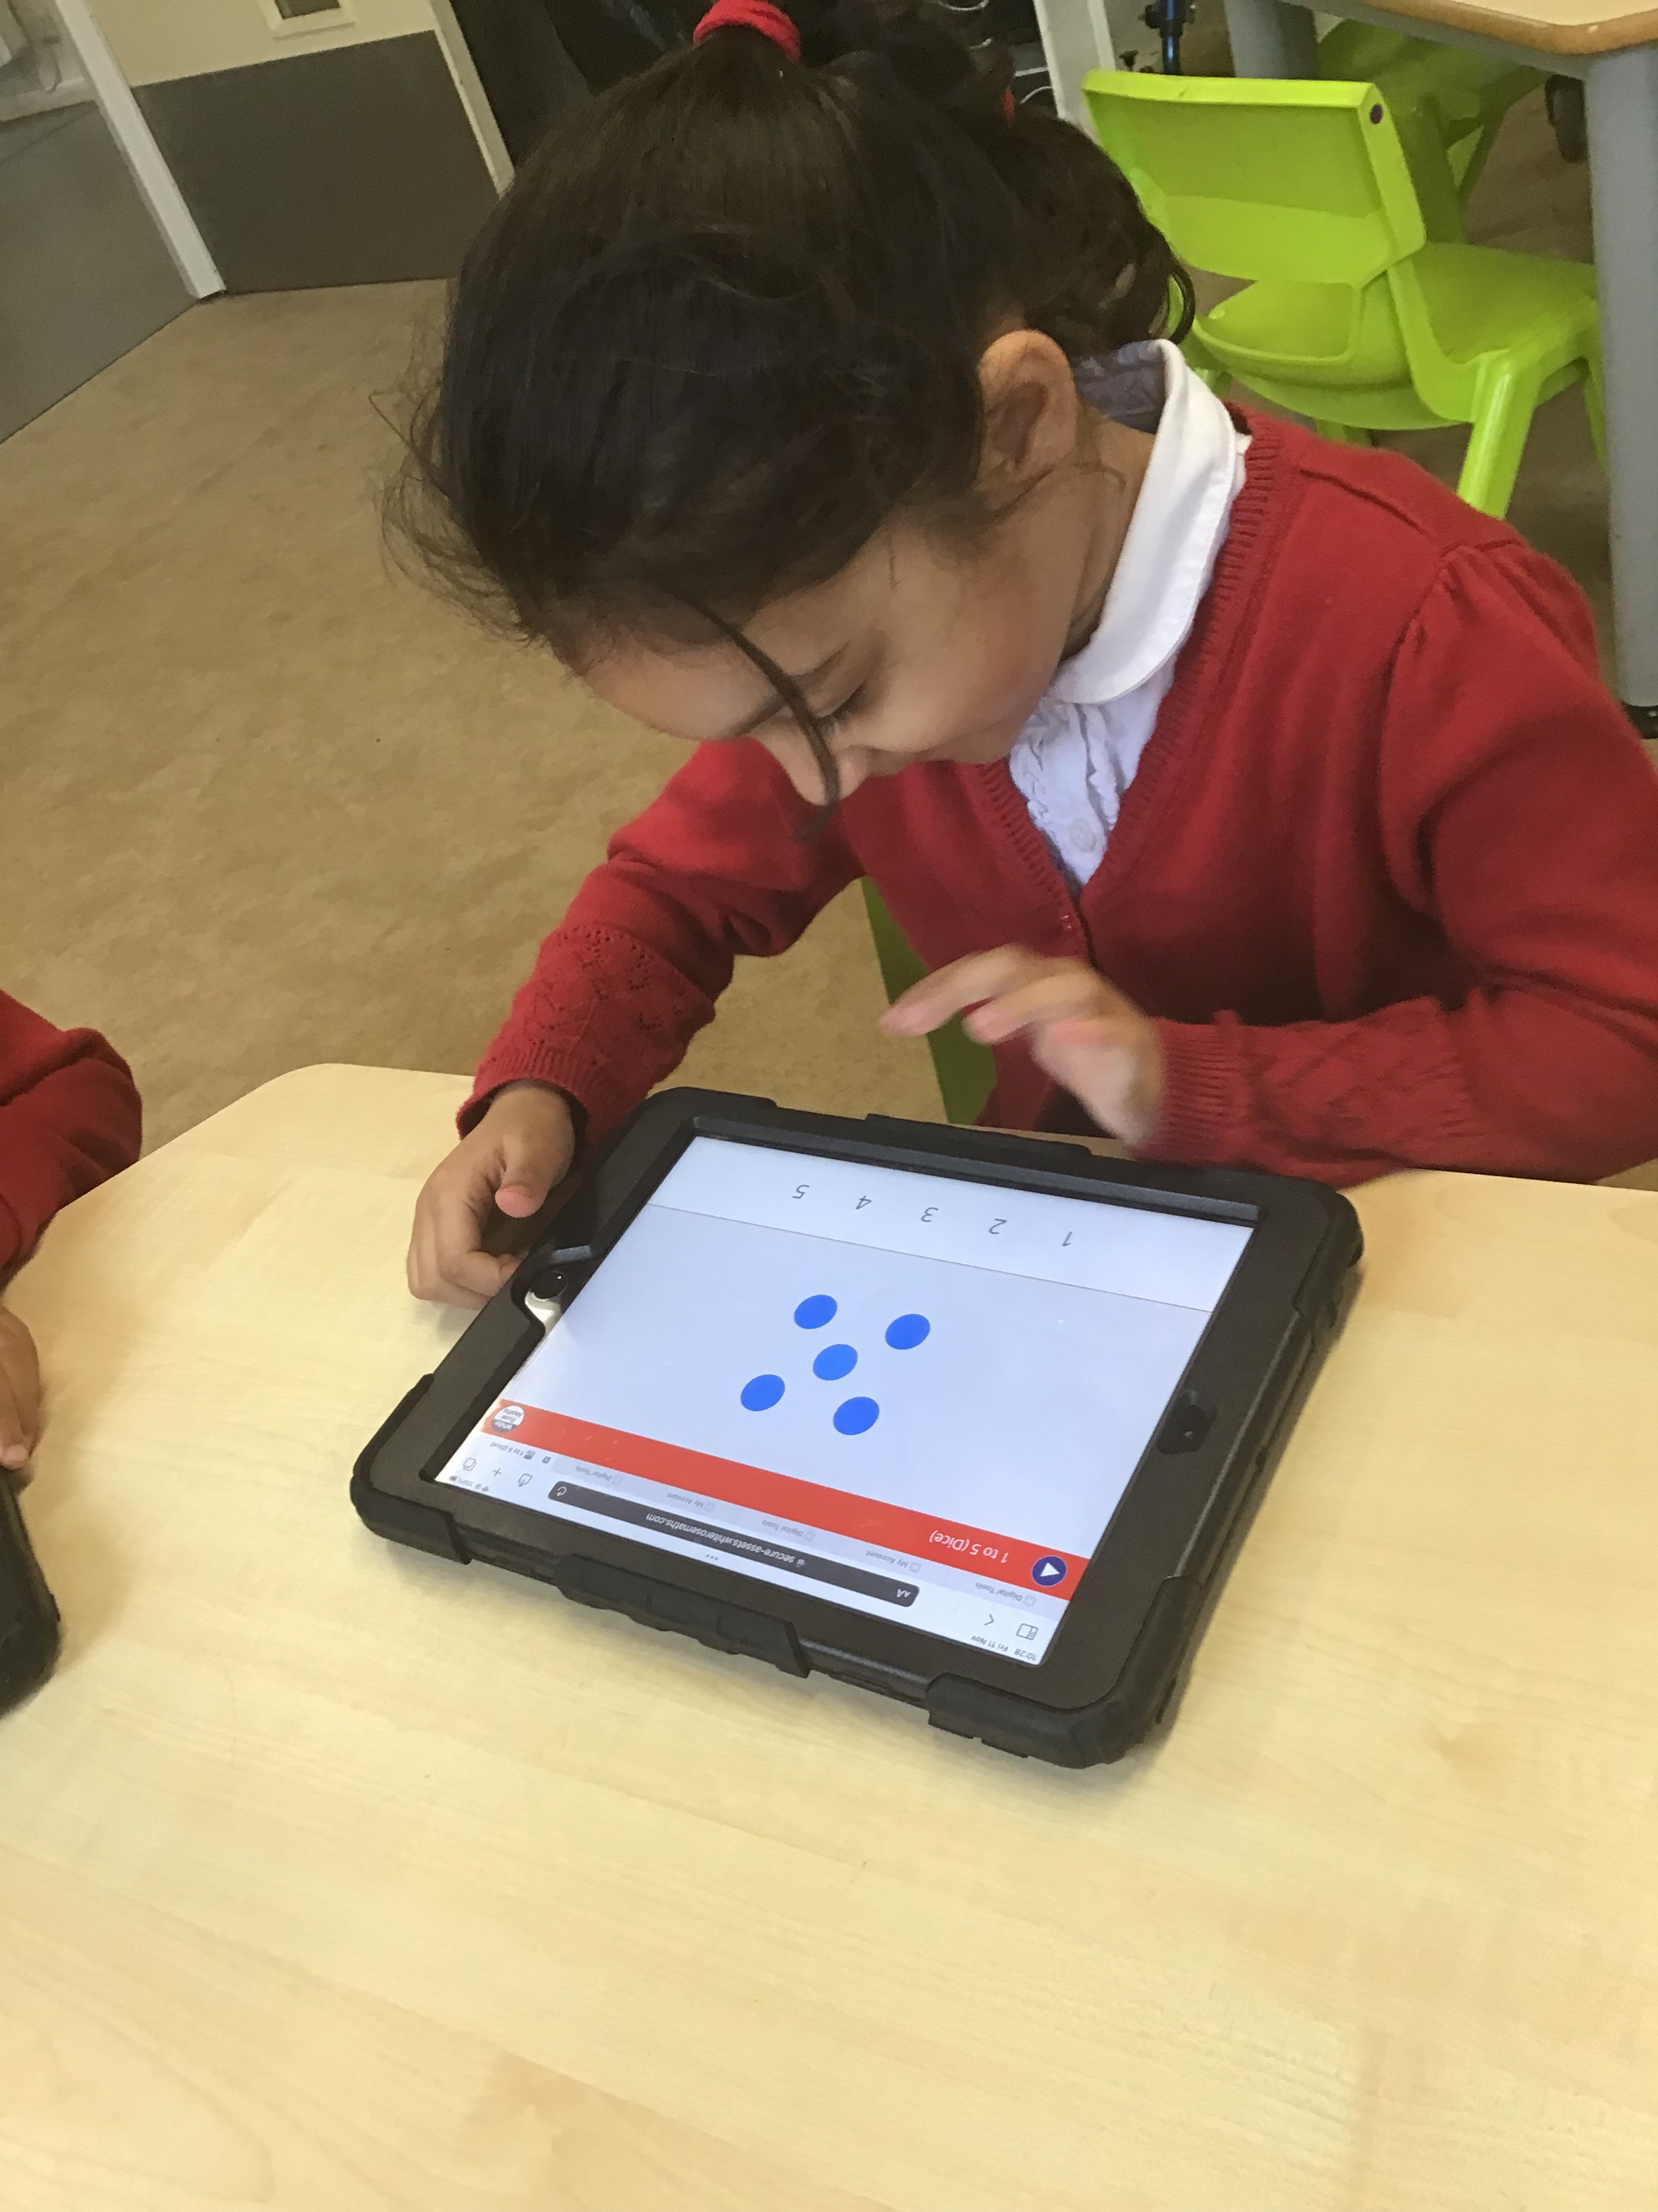
Numberblocks videos and resources for deeper learning.
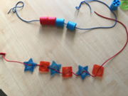
Focus on composition of smaller numbers before moving on.

Consistent modelling of correct mathematical vocabulary.

Number tracks and lines on view and available in provision.

Continuous provision includes various counters, objects for sorting, Numicon, number tracks and lines, items to support numeral recognition, scales, 2d shapes and 3d shapes

Frequent singing of number rhymes and number songs.

Lots of practise subitising, playing ‘fast eyes’ (recognising amounts without counting them) during taught sessions and encouraged throughout daily routines i.e. how many children are in the home corner?

Maths activity recorded regularly in Learning Journals.

Modelled and scaffolded play to introduce how Maths can be linked i.e. measuring distances with throwing and jumping games or keeping score in target games

Children have access to and are encouraged to regularly use the Doodle maths app to practise number skills.

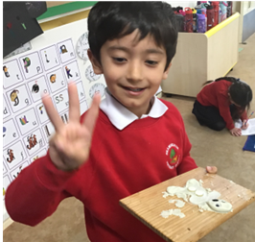
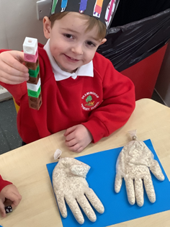
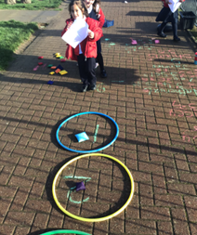

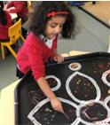
Understanding the World (UW) in Action

Planned carpet sessions as well as learning in the environment, and enhanced provision.

Half termly class topic questions include investigation and exploration to support Understanding the world, for example focusing on other countries and comparing them to each other and what life was like in the past in relation to school, home, transport etc.

Regular discussions about weather and seasons, including how the environment is changing.

Visits to the garden area to look at seasonal changes as well as opportunities to plant vegetables and plants.

Provision of collections of natural objects used i.e. sticks, pine cones, conkers, leaves, shells etc. to encourage children to investigate, discuss and describe.

Visits and visitors planned where possible to support learning, for example professionals from various occupations or visits to the local area and beyond such as farms.

Parents asked to provide family photographs for children to share within the classroom and discuss growth and diversity of families.

Opportunities to learn about concepts of growth, display and change by planting seeds, observing changes in the garden over time, observing lifecycles when we have caterpillars/tadpoles in the classroom.

Encouraging children to look at books and online resources to support learning. Introduce new vocabulary.

Draw children’s attention to forces i.e. how the water pushes up when they try to push a plastic boat under it, how they can stretch elastic, snap a twig but not bend metal, investigating magnetic forces etc.

Provide opportunities for children to change materials from one state to another i.e. melting ice, cooking etc. Explore sinking and floating.

Celebrations from different cultures taught and discussed throughout the year as they arise and through topics.
Varied and diverse texts chosen which support understanding and appreciation of different cultures, countries, disabilities, and lifestyles.

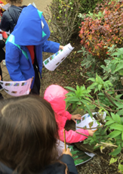
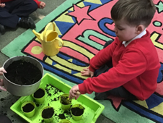
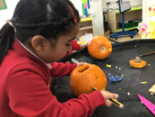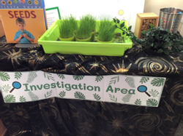

Expressive Arts and Design (EAD) in Action
Provision of a range of materials for children to construct with.

Adult modelling to encourage them to think about and discuss what they want to make, identify problems and how to overcome them, and review their work.
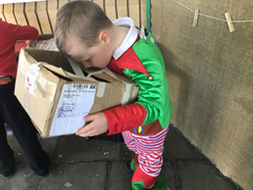
Modelling and teaching of a range of techniques for joining different materials.

Provide a range of artistic materials and tools and teach children how to use them with care and precision.

Develop their drawing skills using a variety of media.

Encourage children to notice features of objects and help them to represent the colour, shape and texture.

Give children an insight into different types of music including music from around the world, linked to topics and celebrations, and encourage them to move to it.

Provide a range of musical instruments to explore. Reception to follow progressive music scheme ‘Charanga’.

Daily singing, encouraging children to follow the pitch and melody.

Provide materials, costumes and props to support children’s pretend play.

Access to a domestic role play all year. Outdoor role play linked to children’s interest or topic.

Daily opportunities to follow choreographed movement through activities such as Jack Hartmann, Go Noodle, Just Dance and Cosmic Yoga.

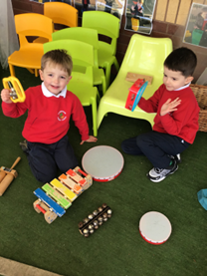
Encourage children to choreograph their own dances.

Children take part in performances for parents.
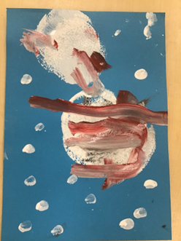
To progress towards our core skill ‘To perform to an audience’.

To progress towards our core skill ‘To make a woodwork model’.

To progress towards our core skill ‘To follow a recipe’.
