24th November 2023

Dear Parents,

We would like to invite you to our Reception Class Nativity performance on Thursday, 14th December at 9.30am.

We have a limited number of seats for the performance, so please click on the link to book your seats. We will allocate up to 2 seats per family and if we have any spare tickets, we will inform you once all families have had the opportunity to book.

Please click on the link below to book your seats by Monday 4th December:
https://forms.office.com/e/gJTMa79kac

We look forward to seeing you.

Yours sincerely

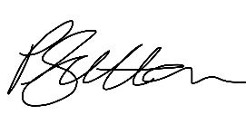
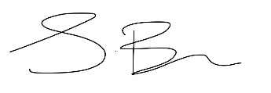

Mrs S Bains and Miss P Sutton
Co- Headteachers

